- Give the output for the following commands:
  - echo “hello world”
echo “hello world”
  - List all the files(hidden included) present in the current directory in long format displaying files in reverse order , sorted based on the modification time .
ls -alrt
  - Change your current password.
passwd
  - How to get the current date
date
  - How to get the current logged in user
whoami
  - How to get the current working directory.
pwd
  - How to get the list of all commands that you have typed so far
history
  - To get the information on the tcp ports
netstat -it
  - To get the information about the running processes.
ps
  - Search for a word in a file. (Hint – grep)
cat file.txt | grep "hello"
  - Search for a specific process. (Hint - use | with ps )
ps | grep “bash”
- Create a directory “exercises” inside your home directory. cd to this new directory.
mkdir exercises
- Create 3 empty files , file1.txt,file2.txt,file3.txt in current directory (exercises).
touch file1.txt file2.txt file3.txt
- Add some text to file1.txt and copy this to ~/exercises/files.
Vi file1.txt
entered content->then pressed escape->typed ZZ to exit
mkdir files
cp file1.txt files
- Copy the entire exercise directory to this files directory.
Cp -R ~/exercise ~/exercises/files
- Create a symlink “testlink” in your home directory that points to this file1.txt i.e. ~/exercises/files/file1.txt.
ln -s ~/exercises/file1.txt ~/exercises/testlink
- Try creating a hard link in your home directory that points to “files” directory .
ln ~/exercises/file1.txt ~/exercises/testhardlink
- Difference between soft and hard link.
Softlinks can be created on directories whereas hardlinks can not be created on directories.
Deleting the original file doesnt make hardlink useless whereas deleting the original file makes softlink useless as the actual file doesnt exist now.

- Change permissions for files directory such that nobody other than the user who created the directory, can write/update anything in that directory.
ls go-w ~/exercises/files
- Create a new user “test”.
Sudo useradd test

- Change the owner of file1.txt to test
sudo chown test file1.txt
- create following directory structure with single command -
home
|-john
|-work
|-scripts
|-bash
mkdir -p john2/work/scripts/bash/
Assume that you are currently in ‘home’ directory.
- Try deleting the ~/exercises/files/exercises directory. See what happens.
cp -R ~/exercises ~/exercises/files/
OUTPUT: can not copy a directory into itself
- A file named employees.odt has a mode of rw-r- -r- -. If John is not the file's owner but is a member of the group that owns this file, what can he do with it?
Read the file.
- Create an alias for clearing the screen.
Alias cls=”clear”
- Create a tar archive of all the files in the current directory.
Tar -cf all.tar *
- How to find if a jar file contains a particular class file?
- How to find all jars with given classname.
Grep file.class *.jar
- How to find files greater than a certain size.
find / -size +5M (for size in MB)
find / -size +5K (for size in KB)
find / -size +5G (for size in GB)

- How do u add and remove a variable in the shell environment.
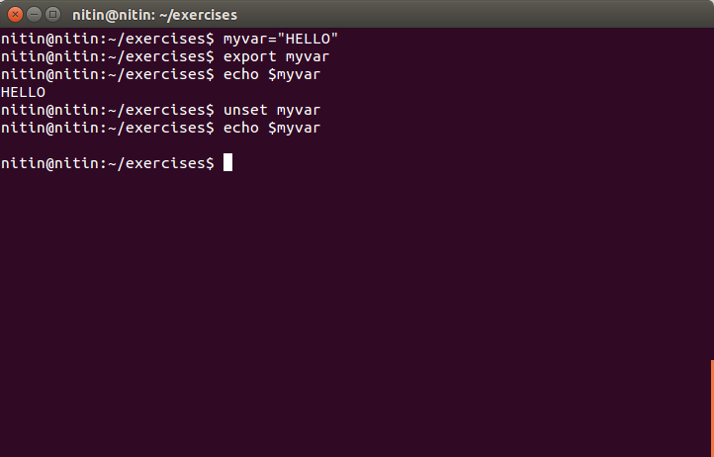
- Install openssh-server on your system
sudo apt-get install openssh-server

- try remote login to your friend’s machine using ssh.
ssh user1@192.168.0.105
- Copy some files from your machine to your friend’s machine. (Hint – scp)
scp ~/hello.txt user1@192.168.0.105

